The Intel vPro® platform increases the value of your ConnectWise Automate platform,
allowing you to remotely manage out-of-band problems down to the BIOS level.

Across industry verticals, MSPs are responsible for managing and securing an increasingly large and diverse array of devices, ranging from traditional business PCs, to IoT devices on the edge, to retail point-of-sale terminals, to headless devices such as digital signage.

MSPs can struggle without a powerful RMM platform like ConnectWise Automate, which automates tasks and decreases your service delivery time, along with the Intel vPro® platform, which gives you cost-effective device management from initial provisioning to retirement. In fact, industry research shows that 40% of MSPs say they aren’t even close to having optimal efficiencies within their organization.1

Intel® Active Management Technology (Intel® AMT) provides the manageability of Intel vPro platformbased devices and includes Intel® Endpoint Management Assistant (Intel® EMA) to let you remotely monitor, restore, upgrade, and help protect devices both inside and outside firewalls. And you can do this all through ConnectWise Automate’s single pane of glass.

Who makes PCs with the Intel vPro platform?
No matter which OEM you prefer, they’ve got a business-class PC with the Intel® Core™ vPro® processor inside. Intel works with OEM and OS partners, running thousands of tests to certify that Intel vPro platform-based PCs meet the rigorous standards for business use cases and power productivity on heavy workloads.
Where can I find Intel vPro platform-based devices?
You can use the Intel vPro Navigator to discover systems already under your management that you haven’t yet provisioned. When looking for new PCs, check out some of the models listed below.

Who makes PCs with the Intel vPro platform?

Dell | Lenovo | HP
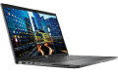  Latitude 7410 | 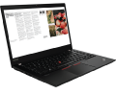  ThinkPad T14 | 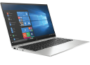  HP EliteBook X360 1040
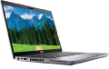  Latitude 5410 | 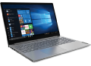  ThinkBook 15 | 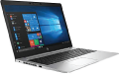  HP EliteBook 850 G7
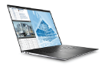  Precision 5750 | 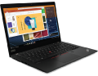  ThinkPad x13 | 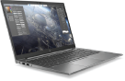  HP ZBook Firefly 14
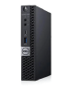  OptiPlex 7080 Micro | 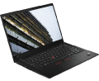  ThinkPad X1 Carbon Gen 8 | HP EliteDesk 800 G5

© Intel Corporation. All rights reserved. Intel, the Intel logo, and other Intel marks are trademarks of Intel Corporation or its subsidiaries.
© 2020 ConnectWise, LLC. All rights reserved. ConnectWise and ConnectWise Automate are trademarks of ConnectWise.
Other names and brands may be claimed as the property of others.

